**PYTHON PROJECT**

**BCSC0053**



**B.TECH(CS)HONORS**

**SESSION 2022-23**

**SUBMITTED TO SUBMITTEDBY**

**ANOOP VERMA SIR Yash Jain**

**Ayush Ponia**



**Discovering Stock Markets**

**Using**

**Python**

**(yfinance)**

**Introduction to Yahoo Finance library yfinance:**

yfinance is a Python library that provides an easy way to download financial data from Yahoo Finance. It is a popular library for fetching stock market data from Yahoo Finance API. This library allows you to get stock market data such as current stock price, historical stock prices, financial statements, and much more. In this project report, we will explore the different functionalities of the yfinance module and how it can be used to fetch financial data from Yahoo Finance.

**Installing yfinance in system:**

yfinance can be installed via pip, which is the standard package manager for Python. You can install yfinance by running the following command in the terminal or command prompt:



**Functionality:**

The yfinance module provides a simple and easy-to-use interface for accessing financial data from Yahoo Finance. Some of the functionalities provided by the yfinance module are:

***1. Ticker:*** The Ticker object is used to get financial data for a particular stock. You can create a Ticker object by passing the stock symbol as a parameter.

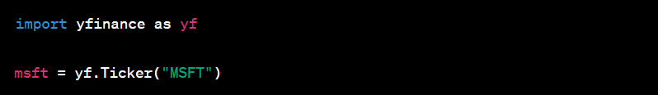

***2. Stock Info***: You can get the basic information about a stock such as the company name, sector, industry, and market cap using the info attribute of the Ticker object.



***3. Historical Data***: You can get the historical data for a stock using the history method of the Ticker object. You can specify the start and end dates for which you want to get the historical data.



***4. Financial Statements:*** You can get the financial statements for a stock such as balance sheets, income statements, and cash flow statements using the financials attribute of the Ticker object.



***5. Dividends:*** You can get the dividends paid by a stock using the dividends attribute of the Ticker object.



***6. Recommendations:*** You can get the analyst recommendations for a stock using the recommendations attribute of the Ticker object.



**Tools and Technologies Used:**

1. Python programming language.

2. yfinance module for fetching financial data.

3. Pandas DataFrame for processing financial data.

4. Matplotlib for visualizing financial data.

**The project will cover the following topics:**

1. Introduction to yfinance module and its installation.

2. Fetching financial data using the Ticker object in yfinance.

3. Analyzing and processing financial data using Pandas DataFrame.

4. Visualizing financial data using Matplotlib and Seaborn.

5. Creating financial models and predicting future trends using financial data.

6. Deploying the financial model using Flask web framework.

**Project Outcome:**

The goal of this project is to analyze financial data using the yfinance module in Python. The project will involve fetching financial data from Yahoo Finance using the yfinance module, processing the data, and visualizing it using various visualization libraries such as Matplotlib.

**Conclusion:**

The yfinance module provides an easy-to-use interface for accessing financial data from Yahoo Finance. It is a powerful tool for financial analysis and can be used for a wide range of applications such as stock trading, portfolio management, and financial research. The module is constantly updated and maintained by the community, ensuring that it is always up-to-date with the latest financial data.